<https://www.cartrade.pk/>

Cities section:

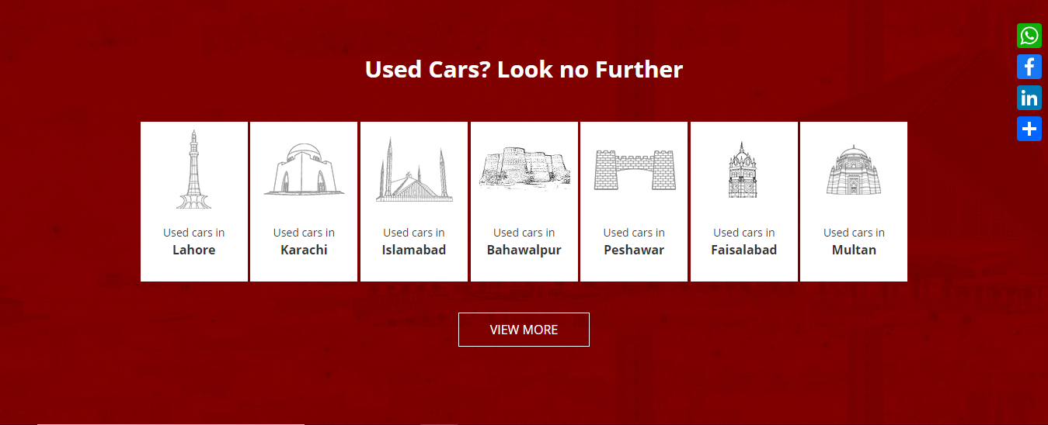

<https://themeforest.net/item/rotors-car-rental-template-for-figma/30492561>

Header

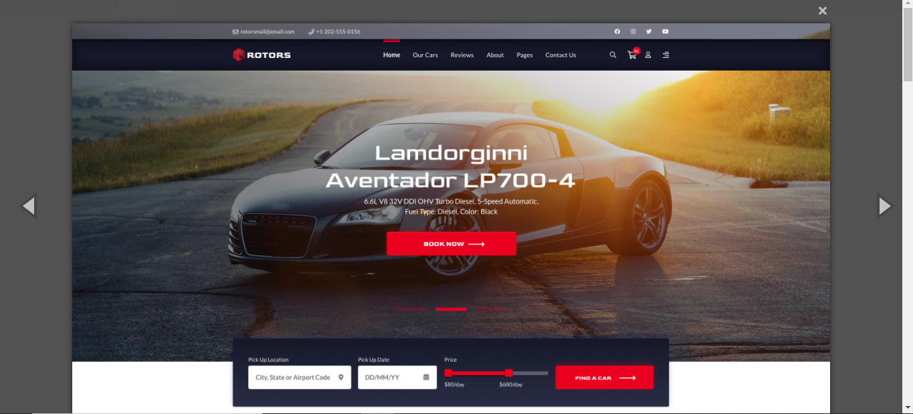

<https://www.cartrade.pk/add-car/>

Form